Assignment #3
Turn in your work as a single file via Blackboard. Make sure your full name is included in the file name. Handwritten answers will not be accepted. Total points: 120.

- Cohesion
The following class is a bus management system, which deals with a number of school buses, drivers, and routes. How can you improve the design by using strong cohesion? (5 points)
public class SchoolBusManager {
private int busNumber;
private int busFee;
private String driver;
…

public int getBusNumber(){
…}

public void getBusRoute(String start, String end){
... }

public void payBusFee(int amount) {
...}
…
}

Answer: we can create 4 different classes: Bus, BusDriver, BusFee and BusRoute with respective private fields and methods declared within these classes. Thus we can keep dependencies local. For example, Bus will store busNumber field and has a method to return that member variable. BusDriver can store information regarding bus driver. BusFee calculates the total bus fee. BusRoute represents and store route and has a method that show route based on start and end routes. We have a SchoolBusManager class which will have collection of these all these classes and corresponding methods. Thus, staying close to the Single Responsibility Principle i.e. each function/class should do only one thing will result high cohesive and reusable code.

- Inheritance
To solve this problem, you may choose an object-oriented language from Java, C#, or C++. In order to receive full credits, your code must not have any bugs. For (a) and (b), turn in your source code and screenshot of test execution.
- Write a pair of classes, Square1 and Rectangle1. Define Square1 as a subclass of Rectangle1. In addition to setters and getters, provide such methods as computeArea and computePerimeter. (8 points)
- Write a pair of classes, Square2 and Rectangle2. Define Rectangle2 as a subclass of Square2. In addition to setters and getters, provide such methods as computeArea and computePerimeter. (8 points)
- Compare (a) and (b) and describe their pros and cons. (9 points)

Answer:

 | Pros | Cons
(a) | Every Square “is-a” Rectangle | a. Square class does not fulfill the contract of the Rectangle class i.e. here the square has to respond to setLength () and setWidth () method calls  b. Each method should do exactly one thing and one thing only but here setSide is trying to do setLength() and setWidth() so it violates the single responsibility principle  c. Square does not need both length and  width member variables. Yet it will inherit them anyway. Clearly, this is wastage of memory size.  d. Square will inherit the setLength and setWidth functions which is not appropriate for Square as both are identical.
(b) | Every Rectangle “is not a” Square unless it’s all sides are equal. | a. To calculate Area of Rectangle and Perimeter of Rectangle we need to modify the source code which violates the Open-Closed Principle.  b. A Square Is Not a Rectangle  It Violates Liskov substitution principle (LSP) i.e. A subclass must fulfill the requirements of all its superclasses.

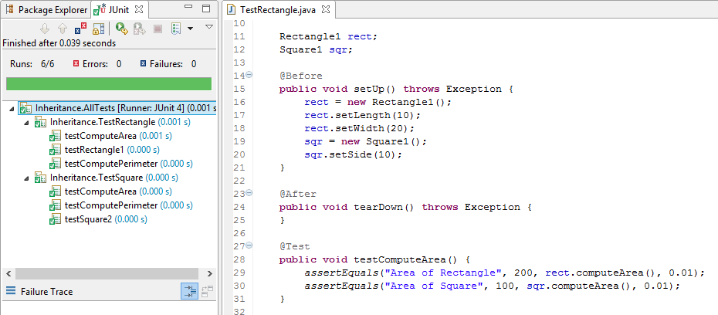
3. Testing
This problem is based on the given Java programs. Do not make any changes to the code. If you choose to use a different object-oriented language, it is your responsibility to translate the code correctly.

Download Triangle.zip and unzip it. The source code has seven Java packages: correct, bug1. bug2,…, and bug6. Each package contains a class Triangle.java. Triangle.java in the “correct” package is a correct program that reports the type (RIGHT, OBTUSE, ACUTE and NOTRIANGLE) of a triangle whose three angles are given as integers (angleA, angleB, angleC). Triangle.java in each bugX (X=1, …, 6) package has a bug.

- Complete the following table of equivalence classes. (15 points)

Condition | Valid classes | Invalid classes
angleA | 1 <= angleA <= 89,  90,  91 <= angleA <= 178  && angleA is whole number | angleA <=0,  negative number,  angleA >=179,  Letters and non-numeric chars,  Invalid number
angleB | 1 <= angleB <= 89,  90,  91 <= angleB <= 178  && angleB is whole number | angleB <=0,  negative number,  angleB >=179,  Letters and non-numeric chars,  Invalid number
angleC | 1 <= angleC <= 89,  90,  91 <= angleC <= 178  && angleC is whole number | angleC <=0,  negative number,  angleC >=179,  Letters and non-numeric chars,  Invalid number
angleA+angleB+angleC=180 | Total sum is 180 | angleA || angleB || angleC <= 0,  angleA || angleB || angleC is negative number

- Complete the following table of boundary values. (15 points)

Variable | Boundary values from valid classes | Boundary values from invalid classes
angleA | 1or 89 or 90 or 91 or 178 | 0 or 179
angleB | 1or 89 or 90 or 91 or 178 | 0 or 179
angleC | 1or 89 or 90 or 91 or 178 | 0 or 179
angleA+angleB+angleC | 180 | 179 or 181

- Complete the following table of test cases only based on the equivalence partitioning in (a) and boundary value analysis in (b). You should add new rows as needed. (15 points)

Test # | Test Input |  |  | Oracle Value  (expected result)
Test # | angleA | angleB | angleC | Oracle Value  (expected result)
1 | 50 | 60 | 70 | ACUTE
2 | 89 | 41 | 50 | ACUTE
3 | 20 | 89 | 71 | ACUTE
4 | 31 | 60 | 89 | ACUTE
5 | 1 | 100 | 79 | OBTUSE
6 | 91 | 19 | 70 | OBTUSE
7 | 10 | 91 | 79 | OBTUSE
8 | 30 | 59 | 91 | OBTUSE
9 | 178 | 1 | 1 | OBTUSE
10 | 1 | 178 | 1 | OBTUSE
11 | 1 | 1 | 178 | OBTUSE
12 | 90 | 1 | 89 | RIGHT
13 | 45 | 90 | 45 | RIGHT
14 | 60 | 30 | 90 | RIGHT
15 | 0 | 10 | 170 | NOTRIANGLE
16 | 50 | 0 | 130 | NOTRIANGLE
17 | 80 | 120 | 0 | NOTRIANGLE
18 | 179 | 10 | 1 | NOTRIANGLE
19 | 20 | 179 | 10 | NOTRIANGLE
20 | 100 | 50 | 179 | NOTRIANGLE
21 | 181 | 15 | 50 | NOTRIANGLE
22 | 15 | 181 | 50 | NOTRIANGLE
23 | 16 | 27 | 181 | NOTRIANGLE
24 | 0 | 0 | 0 | NOTRIANGLE
25 | -10 | 120 | 70 | NOTRIANGLE
26 | 100 | -20 | 100 | NOTRIANGLE
27 | 95 | 120 | -30 | NOTRIANGLE
28 | 1 | 1 | 1 | NOTRIANGLE

- Write a Junit class TriangleTest.java in the “correct” package to implement all the test cases in (c). A sample test is given below. Run and debug TriangleTest.java in the “correct” package until there is no failure (if there is a failure, then something is wrong with your tests and you must fix it). Turn in your source code and include a screenshot of your test execution in this Word document. (15 points)
public void testAcuteTriangle () {
Triangle triangle = new Triangle(50, 60, 70);
assertTrue(triangle.reportTriangleType()==Triangle.TriangleType.ACUTE);
}

Answer: I have added total 28 test cases with random integer values for angles and boundary condition values and all the test have been passed for correct package as shown below:

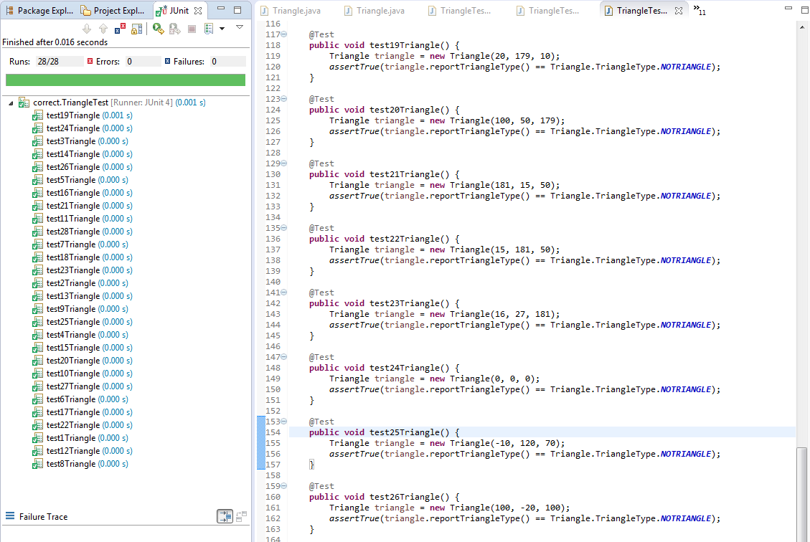
Fig. : Correct Test Cases

- Based on the test cases in (c), complete the following table about coverage of each conditional statement in the correct program (15 points).

Conditional statement | Is branch coverage achieved? |  | Is multi-condition coverage achieved?
Conditional statement | Yes/No | If yes, list the test cases that achieved the branch coverage | Yes/No | If yes, list the test cases that achieved the multi-condition coverage
if (angleA <= 0 || angleB <= 0 || angleC <=0) | Yes | True: 15 to 17 and 24 to 27  False: 1 to 23 and 28 | Yes | True: Branch1 angleA <= 0 : 15, 24 and 25  Branch2 angleB <= 0 : 16, 24 and 26  Branch3 angleB <= 0 : 17, 24 and 27  False: 1 to 23 and 28
if (angleA+angleB+angleC!= 180) | Yes | True: 18 to 23 and 28  False: 1 to 14 | N/A | N/A
if(angleA== 90 || angleB == 90 || angleC == 90) | Yes | True: 12 to 14  False: 1 to 11 | Yes | True: Branch1 angleA== 90 : 12  Branch2 angleB == 90 : 13  Branch3 angleC == 90 : 14  False: 1 to 11
if(angleA > 90 || angleB > 90 || angleC > 90) | Yes | True: 5 to 11  False: 1 to 4 | Yes | True: Branch1 angleA > 90: 6,9  Branch2 angleB > 90: 5,7,10  Branch3 angleC > 90: 8,11  False: 1 to 4

- Copy your TriangleTest.java in (d) to each bugX (X=1, 2, …, 6) package. Make sure the package statement in TriangleTest.java is correct so that you can test Triangle.java in the same package. Report your test results in the table below and include in this Word document a screenshot of test execution for each bugX package. (15 points)
Note: To get full credits for (a), (b), and (c), your tests must be able to find at least 4 of the bugs. These tests must result from the techniques in (a) and (b).

Bug Version | Test failure: Yes or No? | If Yes, list the tests that failed; If No, explain why
1 | yes | Test # 5, 11, 10
2 | yes | Test # 28
3 | yes | Test # 14
4 | yes | Test # 11
5 | yes | Test # 8
6 | yes | Test # 8

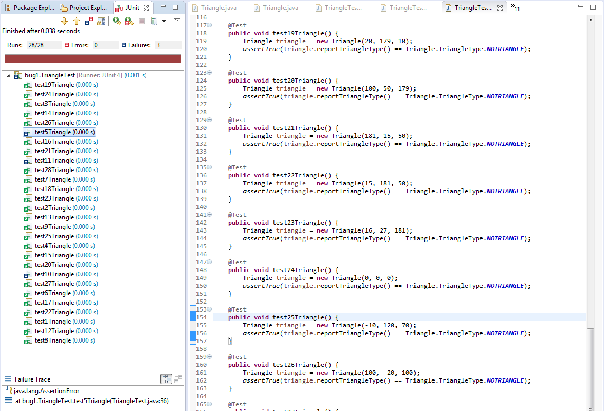
Fig. : Bug 1
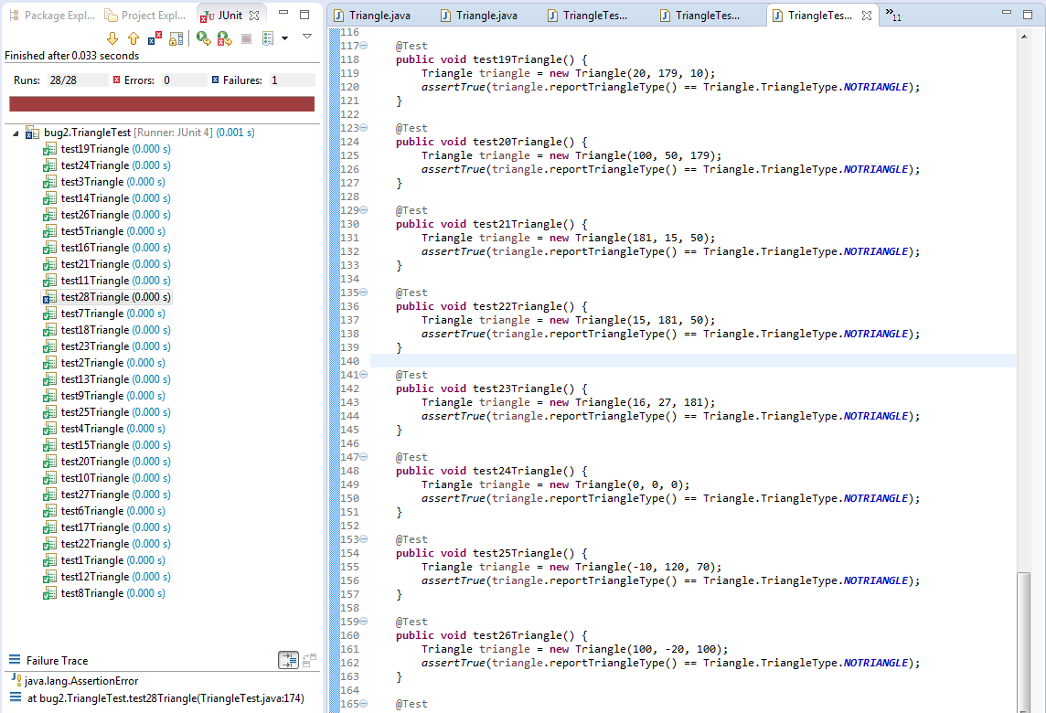
Fig. : Bug 2

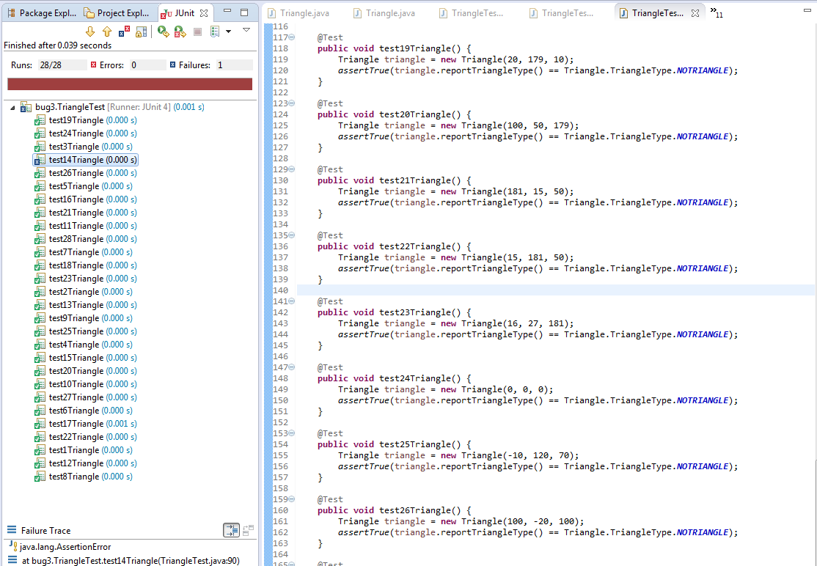
Fig. : Bug 3
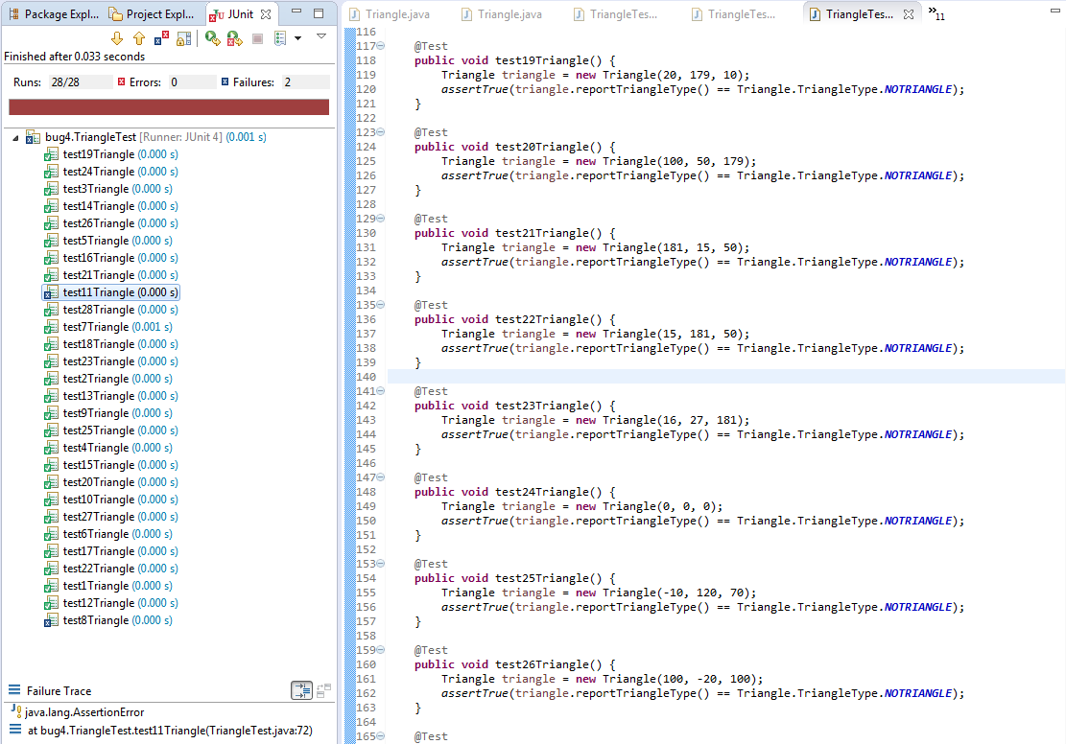
Fig. : Bug 4
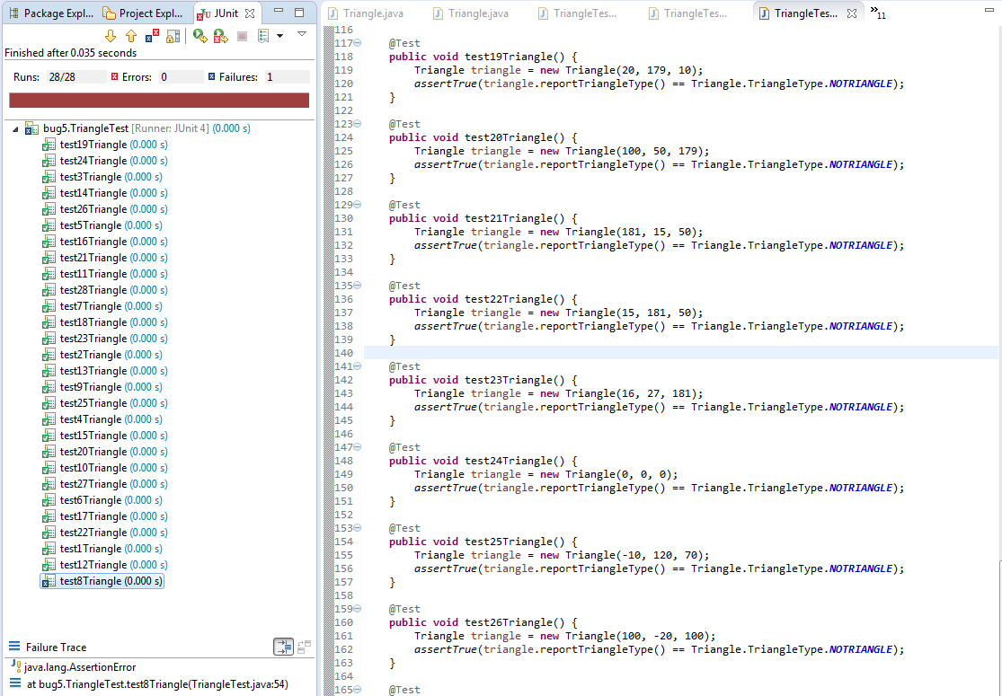
Fig. : Bug 5
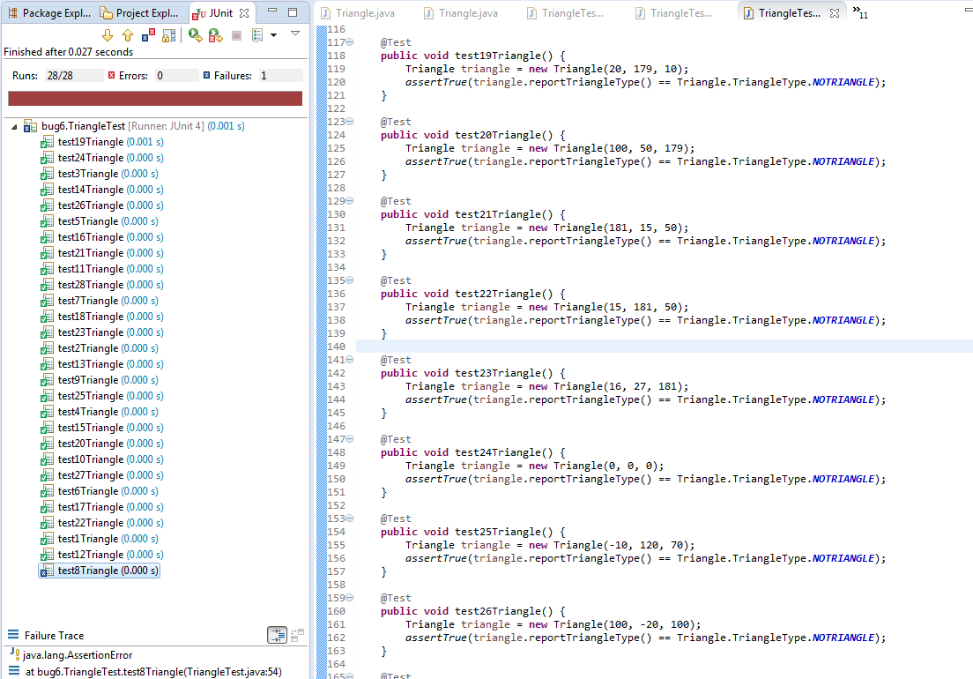
Fig. : Bug 6

